**COMSATS University Islamabad, Attock Campus**



## Project Name

## Semester Schedule System

### *By*

**Student Name 1**

**Muhammad Shehzad**

CIIT/FA16-BCS-039/ATK

**Student Name 2**

**Saleem Khan**

CIIT/FA16-BCS-051/ ATK

#### *Supervised By:*

**Mr. Shahzad Rizwan**

### *Bachelor of Science in Computer Science (2020-2021)*

**The candidate confirms that the work submitted is their own and appropriate credit has been given where reference has been made to the work of others**.

# DECLARATION

We hereby declare that this software, neither whole nor as a part has been copied out from any source. It is further declared that we have developed this software and accompanied report entirely on the basis of our personal efforts. If any part of this project is proved to be copied out from any source or found to be reproduction of some other. We will stand by the consequences. No Portion of the work presented has been submitted of any application for any other degree or qualification of this or any other university or institute of learning.

Student Name 1 Student Name 2

Muhammad ShehzadSaleem Khan

--------------------------- ---------------------------

**CERTIFICATE OF APPROVAL**

It is to certify that the final year project of BS (CS) “Project title” was developed by

**Muhammad Shehzad (CIIT/FA16-BCS-039)** and **Saleem Khan** **(CIIT/FA16-BCS-051)** under the supervision of “Mr. Shahzad Rizwan” it is fully adequate, in scope and quality for the degree of Bachelors of Science in Computer Sciences.

Mr. Shahzad Rizwan

---------------------------------------

**Supervisor**

---------------------------------------

**External Examiner**

**Dr. Khalid Awan**

---------------------------------------

**Head of Department**

**(Department of Computer Science)**

# Executive Summary

In public places, there is often a need for monitoring people and different activities going on, which can be referred later for many reasons including security. Appointing humans for this task involves many problems such as increased employee hiring, accuracy problem, trust, no proof for later use, and also the fact that a human can remember things till a certain time limit. Talking about the current security system, they use dumb still cameras with a continuous recording facility ire-respective of the fact that any event may happen or not. Moreover they are usually pointing at a specific user defined locations so more than one cameras are required to cover the entire region.

To prevent all these problems from prevailing, the CSCS is developed. It is a surveillance system, which provides solution to many of these problems. It is a stand-alone application which doesn’t require any computer to operate. It monitors different situations using a camera which is able to rotate intelligently based on sensor messages and captures the scene in the form of video or photos later reference as well.

**C**ustomizable **S**urveillance **C**ontrol **S**ystem **(CSCS)** is a surveillance system that can be assigned a sensor type as in our case a heat sensor is used, it works accordingly, rotates the camera upon event detection and perform user defined actions like capturing video and stores them, for the future use.

It is an embedded system consisting of Linux fox kit with embedded a running server application also a camera, USB storage device and a sensor node base station is attached with fox kit. LAN communication is used by user to download the videos and to operate the system manually.

# Acknowledgement

All praise is to Almighty Allah who bestowed upon us a minute portion of His boundless knowledge by virtue of which we were able to accomplish this challenging task.

We are greatly indebted to our project supervisor “Mr. Shahzad Rizwan”

Without their personal supervision, advice and valuable guidance, completion of this project would have been doubtful. We are deeply indebted to them for their encouragement and continual help during this work.

And we are also thankful to our parents and family who have been a constant source of encouragement for us and brought us the values of honesty & hard work.

Student Name 1 Student Name 2

Muhammad Shehzad Saleem Khan

--------------------------- ---------------------------

# Abbreviations

|  |  |
| --- | --- |
| **SRS** | Software Require Specification |
| **PC** | Personal Computer |
|  |  |
|  |  |
|  |  |

**Table of Contents**

Chapter No.1 8

Introduction 8

1.1. Introduction 9

1.2. Brief about the project 10

1.3. Relevance to Course Modules 10

1.3.1. OOP: 10

1.3.2. SE-1: 11

1.3.3. Machine Learning: 11

1.3.4. DAA: 11

1.3.5. Database Design: 11

1.3.6. MPL: 11

1.4. Project Background 11

1.5. Literature Review 12

1.6. Analysis from Literature Review (in the context of project) 12

1.7. Methodology and Software Lifecycle for This Project 12

1.7.1. Rationale behind Selected Methodology 12

Chapter No.2 14

2: Problem Definition 14

2.1: Problem Statement: 15

2.2.2: Development Requirements: 16

2.3: Current Systems: 17

Chapter No.3 17

Requirement Analysis 17

3.1.1 Requirement Templates: 26

Chapter No.4 30

Design and Architecture 30

Chapter No 5: 31

Implementation ............................................................................................................................. 56

5.1. Algorithm ..............................................................................................................................56

5.2. External APIs ........................................................................................................................56

5.3. User Interface

Chapter No 6:...........................................................................................................................56

Testing and Evaluation ............................................................................................................ 57

Manual Testing .............................................................................................................57

6.1. System testing ........................................................................................................57 6.1.2 Unit Testing ...............................................................................................................57

6.1.3 Functional Testing ...............................................................................................58

6.1.4 Integration Testing..... ........................................................................................58

6.2 Automated Testing: ........................................... ..................................................59

Chapter No7.................................................................................................... ...................

8 Conclusion and Future Work ............................................................................................ 60

8.1 Conclusion ..........................................................................................................................60

8.2 Future Work ......................................................................................................................60

Chapter No 8: ........................................................................................................................

References ............................................................................................................................ 61

# List of Figures

Fig 1.1 Block Diagram ......................................................................................................................................................8

Fig 2.1 Use Case Diagram ......................................................................................................................................................9

# Chapter No.1

Introduction

## Introduction

Time is a very important key factor in life. Especially the life of students and teachers are busy scheduled life. They are so busy that they forgot to meet the deadlines. Commonly, students forgot to submit assessments on time, and it affects their grades or also teachers forgot to update student’s grades on the portal within the due date. This problem left students and teachers with a big loss and they cannot manage time to meet deadlines.

Time management is very important for both teachers and students, thus proposing a system that will schedule the semester for teachers and students and notify both before deadlines. This system facilities the students and faculty by saving their time and reduces the efforts of students and teachers. Semester schedule system provides the complete calendar of the semester it provides the facility to teachers to schedule the Quizzes and Assignments. Students will be notified about deadlines via application. Teachers can also change the schedule dates make delays in Quizzes and Assignments and can postpone the Quizzes and Assignments. Students and Teachers will be notified before deadlines for each of the following events.

* (Course/ Thesis) Registration
* Orientation Ceremony
* Commencement of Classes
* Last Date for "Fee Refund Application"
* Campus Convocation
* Last Date for Drop of Courses (For Student)
* Last Dates of Submitting Assignments (For Student)
* Dates for Quizzes Schedule by Subject Teacher (For Student)
* Last Dates for Uploading Minimum Quizzes and Assignments (For Teachers)
* Start of 1st Sessional’
* Student Week
* Last date for withdrawal of courses/semester
* Start of Mid-Term for Graduate
* Start of 2nd Sessional
* 50% Result Notification with Quizzes and Assignments

## Brief about the project

The Semester schedule system will be designed to facilitate the students and teachers. Currently, there is no such system exists that notify teachers and students before any events. Management prepares the schedule in hard forms and that printed paper stitched on noticeboard. Not every student and teacher can get access to the noticeboard daily so they miss some important events happening in university. Some time students forgot to submit instalments on time so they got fine and then pay with extra fine so our system will notify students on their smartphones before the last date of submitting any instalment. Some teachers forgot to take assignments or quizzes on time so they can’t upload student grades before the deadline of uploading marks on portal. Teachers will notify about every event before the deadlines. Also, teachers can set the last date of submission for assignments to notify students that this particular assignment must be submitted before the due date they will award with grades. Teachers can also announce quiz dates for their classes and they can also postpone or change the assignment or quiz submission date. The system will work on an expert system where the system will be guided through reading a pdf or word file system will read that entire file and store those events along with dates in the database. The system will be trained to notify every user before every event so they can’t miss the event and everyone can meet the deadline.

## Relevance to Course Modules

The project is related to different courses that we have studied in our degree. The course modules closely related to this project are as following.

### Object Oriented Programming (OOP)

To design the project application Object Oriented Programming Design (OOD) methodology is used. We studied the implementation of OOP using Java programming language. The knowledge we gained from this course will be helpful in our project.

### Software Engineering-1 (SE-1)

For documentation and designing of the whole system SE-1 methodology is used and also deciding which Software Development Life Cycle (SDLC) methodology is best suited for this project.

### Machine Learning

We will be using machine learning algorithms in our project for the classification purposes. The algorithms that we learnt in this course will be helpful in our project.

### Design and Analysis of Algorithm (DAA)

For designing an algorithm that has good time and space complexity is a requirement of this project. We will be applying methods studied in this course.

### Database Design

The Database Design course was studied in BCS degree is all about designing and implementing databases. The techniques and method for designing a good database that will be implemented in this project.

### Modern Programming Language (MPL)

The Android Studio in Modern Programming Language Course was studied in BCS degree program that will help in designing and developing the whole system for android smart phones.

## Project Background

As you know the project is related to University Semester Schedule System that will facilitate the students and teachers in the form of deliverable product as an android app. The system will be trained using an expert system and the system has to notify the student and teachers about the event before the deadline of the event.

## Literature Review

### There is no past work on this project. University is using the traditional way of communication to communicate with students and teachers. University management display notifications or any event schedule on noticeboard and there is no other application that is currently working on it to notify students and teachers via application about events etc.

## Analysis from Literature Review (in the context of project)

Displaying schedules and notifications on noticeboard is the older technique now everyone has smart phone thus the system will provide the facilities to the teachers and students by sending them notifications about any event or about the semester’s deadline.

## Methodology and Software Lifecycle for This Project

The methodology used in this project is the OOD. In the OOD methodology each entity is considered as a class. The classes are the abstract representation of an object. The OOD provides easy way to maintain software and these objects can be reused across application.

Agile development is used for this project. Agile development is that a project is divided into multiple sprints. Sprints are nothing but a period of time allocated to phase of a project and after each sprint the completed part of the project is shown to the stake holder, development team also.

### Rationale behind Selected Methodology

The reason behind selecting OOD as methodology for this project is that Object Oriented Design will provide a clear modular structure of the application. The components in OOD are reusable and can be used in developing other application. The code is easier to maintain which we will be pro. The OOD is easily adaptable and can be modified by the programmers which makes it easy for us or any new programmer who wants to add new features or work on this project in future.

Agile development is used in this project as the SDLC because it is divided into stages and modules. The Agile development will enable to complete the working modules and meet the deadlines of our evaluation. Agile development also helps in early risk reduction and getting timely feedback from customer/client. During the development and also after completion of the modules we can show our progress to our supervisor and get feedback. If work done till now is according to the requirement.

# 

# Chapter No.2

# Problem Definition

## 

## 2.1: Problem Statement:

# Time is a very important key factor in life. Especially the life of students and teachers are busy scheduled life. They are so busy that they forgot to meet the deadlines. Commonly, students forgot to submit assessments on time and it affects their grades or also teachers forgot to update the student’s grades on the portal within the due date. This problem left students and teachers with a big loss and they can't manage time to meet deadlines.

* Time management is very important for both teachers and students, so we are proposing a system that will introduce a semester schedule for teachers and students and notify both before deadlines. This system facilities the students and faculty by saving their time and also reduces the efforts of students and teachers. Semester schedule system provides the complete calendar of the semester it provides the facility to teachers to schedule the Quizzes and Assignments.

**2.2.1: Deliverables:**

Deliverables and Development requirements of our project are following.

#### Deliverables of Project

* + Proposal Document
  + Software Requirement Specification (SRS).
  + Mobile Application
  + Database for Mobile application
  + Software Design Specification
  + Add Schedule

### 2.2.2: Development Requirements:

|  |  |  |  |
| --- | --- | --- | --- |
| **Development And**  **Requirements** | **Tools** | **Version** | **Rationale** |
| Android Studio | 3.3.2 | AS |
| Adobe Photoshop | CSC 6 | Design Work |
| MS Word | 2016 | Documentation |
| MS Power Point | 2016 | Presentation |
| **Technology** | **Version** | **Rationale** |
| MS SQL Server | 16.0.8 | Real-time database |
| Java | 7 | Programming language |
| XML | 5 | UI Designs |
|  | Python | 3.2 | Programming language |

## 2.3: Current Systems:

|  |  |  |
| --- | --- | --- |
| **Application Name** | **Weakness** | **Proposed Project Solution** |
| My Study Life | Algorithm | Used another algorithm |
| Time Table Planner | Buggy/Not Working | Bug should be fixed |

# 

# Chapter No.3

## Requirement Analysis

**3.1): Use Cases Diagram(s)**

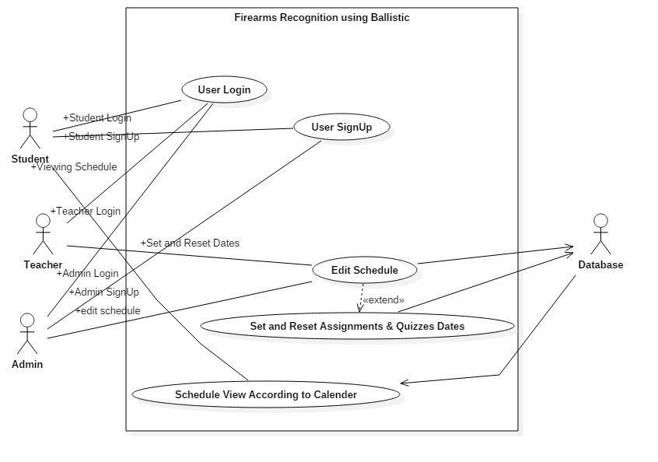

**Figure 3.1: Firarms recognitions using Ballistic**

**3.2): Detailed Use Case**

Table 1: Use Case 1 (User Login)

|  |  |
| --- | --- |
| **Use Case ID:** | **1** |
| **Use Case Name:** | User Login |
| **Actors:** | Primary Actor: User |
| **Description:** | In the startup view of application, there is login page where user will enter his credentials to login in his account. But before that user must have login credentials. |
| **Trigger:** | 1. User wants to predict about any case. 2. Check case studies |
| **Preconditions:** | PRE-1. System should not be logged in before.  PRE-2. User must have credentials to login. |
| **Post conditions:** | The user will able to predict about image. |
| **Normal Flow:** | 1. Open application on system. 2. Put Email in required email input field. 3. Put Password related to that email account. 4. Click on Login button to go further. 5. Home page will appear if credentials are verified. 6. Error will appear on screen if credentials are wrong. |
| **Alternative Flows:** | There is no alternative way to login to the application user must have to access to application first to logged in. |
| **Exceptions:** | 1. User doesn’t have account already. 2. Server out of order. 3. Forgot Password. |
| **Business Rules** | None |
| **Assumptions** | 1. User login at daily basis. |

|  |  |
| --- | --- |
| **Use Case ID:** | **2** |
| **Use Case Name:** | Create User Profile. |
| **Actors:** | Primary Actor: User |
| **Description:** | If user doesn’t have account already, so first, user will create its profile to access application for further uses. Once user profile created user can login anytime using their credentials. |
| **Trigger:** | New User. |
| **Preconditions:** | PRE-1.Signed Out. |
| **Post conditions:** | 1. The user will able to predict about image. 2. User can use application for their purposes. |
| **Normal Flow:** | 1. Open application on system. 2. Click on don’t have account. 3. Fill required form. 4. Click on Signup button. |
| **Alternative Flows:** | None |
| **Exceptions:** | Admin didn’t verify account. |
| **Business Rules** | None |
| **Assumptions** | None |

Table 2: Use Case 2 (Create User Profile)

**Table 3: Use Case 3 (Edit Schedule)**

|  |  |
| --- | --- |
| **Use Case ID:** | **3** |
| **Use Case Name:** | Edit Schedule |
| **Actors:** | Primary Actor: Teacher and Admin Secondary Actor: Database |
| **Description:** | Teacher and Admin can edit the schedule and update it on database. |
| **Trigger:** | Changes in Schedule. |
| **Preconditions:** | PRE-1.Signed In. |
| **Post conditions:** | 1. User can View Schedule as well. |
| **Normal Flow:** | 1. Sign in first. 2. Make Changes in Schedule. 3. Update Changes in Database. 4. View Changes. |
| **Alternative Flows:** | None |
| **Exceptions:** | User doesn’t make changes. |
| **Business Rules** | None |
| **Assumptions:** | None |

**Table 4: Use Case 4 (Set and Reset Assignments and Quizzes dates)**

|  |  |
| --- | --- |
| **Use Case ID:** | **4** |
| **Use Case Name:** | Set and Reset Assignments and Quizzes dates |
| **Actors:** | Primary Actor: Teacher and Admin Secondary Actor: Database |
| **Description:** | Teacher and Admin can edit the schedule and update it on database and also teacher have access by admin that teacher can update quizzes assignments dates. |
| **Trigger:** | Changes in Schedule. |
| **Preconditions:** | PRE-1.Signed In. |
| **Post conditions:** | 1. User can View Schedule as well. |
| **Normal Flow:** | 1. Sign in first. 2. Make Changes in Schedule. 3. Update Changes in Database. 4. View Changes. |
| **Alternative Flows:** | None |
| **Exceptions:** | User doesn’t make changes. |
| **Business Rules** | None |
| **Assumptions:** | None |

**Table 5: Use Case 5 (Schedule view according to calendar)**

|  |  |
| --- | --- |
| **Use Case ID:** | **5** |
| **Use Case Name:** | Schedule view according to calendar |
| **Actors:** | Primary Actor: Teacher, Admin and Student Secondary Actor: Database |
| **Description:** | Teacher, Admin and Student can view the Semester Schedule along calendar with mentioned dates with events |
| **Trigger:** | Viewing Schedule. |
| **Preconditions:** | PRE-1.Signed In. |
| **Post conditions:** | none |
| **Normal Flow:** | 1. Sign in first. 2. Click on require date. 3. Or click on whole semester Schedule. 4. View . |
| **Alternative Flows:** | None |
| **Exceptions:** | User doesn’t make changes. |
| **Business Rules** | None |

**3.3): Functional Requirements**

The functional requirements of system are as follows:

* Sign In
* Sign Up
* Edit Schedule
* Set and Reset Assignments and Quizzes dates
* Schedule view according to calendar

***Requirement Templates:***

**Table 8: Sign In**

|  |  |
| --- | --- |
| **Identifier** | 1 |
| **Title** | Sign In |
| **Requirement** | Need of this function is to maintain User profile, so that whenever user want check schedule of all the days it will be easy for them. |
| **Source** | To maintain User profile so it is easy to track back that who had originated any specific case. |
| **Rationale** | Maintain user’s record in database. |
| **Business Rule (if required)** | User must have authorized profile. |
| **Dependencies** | 3,4,5,6,7 |
| **Priority** | High |

**Table 9: Sign Up**

|  |  |
| --- | --- |
| **Identifier** | 2 |
| **Title** | Sign Up |
| **Requirement** | When users don’t have credentials to login so user must have to signup first. Admin will authorize user to access application. |
| **Source** | In order access application user must have account. |
| **Rationale** | Access to application functionalities. |
| **Business Rule (if required)** | User profile must be authorized by admin. |
| **Dependencies** | 3,4,5,6,7 |
| **Priority** | High |

**Table 10: Edit Schedule**

|  |  |
| --- | --- |
| **Identifier** | 3 |
| **Title** | Edit Schedule |
| **Requirement** | When new semester will start New Schedule will be updated on database according to the calendar. Edit or updates can be done by teachers as well they can schedule assignments and quizzes for students. |
| **Source** | In order access application user must have account. |
| **Rationale** | Access to application functionalities. |
| **Business Rule (if required)** | User profile must be authorized by admin. |
| **Dependencies** | 3,4,5,6,7 |
| **Priority** | High |

**Table 11: Set and Reset Assignments and Quizzes Dates**

|  |  |
| --- | --- |
| **Identifier** | 3 |
| **Title** | Set and Reset Assignments and Quizzes Date. |
| **Requirement** | Teachers can also update and edit the date of assignments and quizzes according to the schedule. Either they will cancel the Quizzes and Assignments or update or postpone the date. |
| **Source** | In order access application user must have account. |
| **Rationale** | Access to application functionalities. |
| **Business Rule (if required)** | User profile must be authorized by admin. |
| **Dependencies** | 3,4,5,6,7 |
| **Priority** | High |

**Table 12: Schedule view according to calendar**

|  |  |
| --- | --- |
| **Identifier** | 3 |
| **Title** | Schedule view according to calendar. |
| **Requirement** | Every User can view the schedule and updated of every events. |
| **Source** | In order access application user must have account. |
| **Rationale** | Access to application functionalities. |
| **Business Rule (if required)** | User profile must be authorized by admin. |
| **Dependencies** | 3,4,5,6,7 |
| **Priority** | High |

**3.4):Non-Functional Requirements**

**Cross Platform Compatibility**

The Application should be able to run on multiple operating systems i.e. Windows, Linux etc.

**Usability**

It should have user friendly interface and should be easy to learn

**Efficiency**

System should be efficient. The results should take less time to computer and display.

**Robustness**

System should recover from errors and error rate should be low.

# 

# Chapter No.4

## Design and Architecture

## 4. Design and Architecture

The following parts of Software Design Description (SDD) report should be included in this chapter.

**4.1. System Architecture of Semester Schedule System**

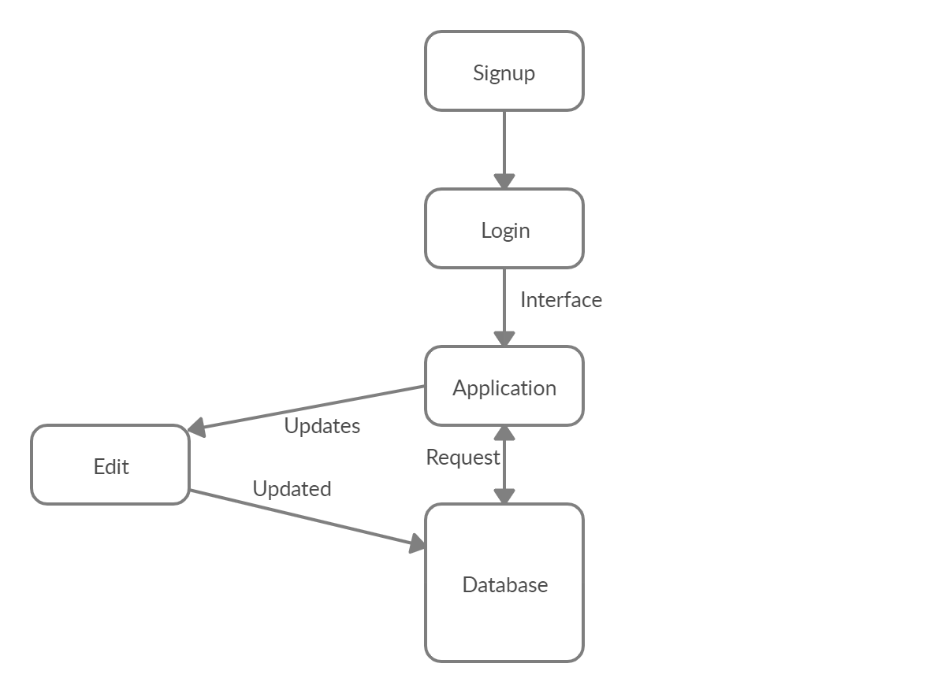

**Figure 4.1: System Architecture of Semester Schedule System**

**4.2. Data Representation [Diagram + Description]:**

A Data Flow Diagram (DFD) is graphical interpretation of information move from a data framework. A DFD is used for basic step to create an overview of the system without going into great aspect, which can later be elaborated.

Provide data

User

System

Sh Show result

**Figure 4.2: Data Flow Diagram of the System**

**4.3. Process Flow/Representation**

**4.3.1. Activity diagram**

A close up of a map

Description generated with very high confidence

**Figure 4.3: Activity Diagram of the System**

**4.3.2. Sequence Diagram**

A screenshot of a cell phone

Description generated with very high confidence

**Figure 4.4: Sequence Diagram of the System**

Chapter No 5

Implementation

## Implementation

This chapter will discuss implementation of our project in this portion we will discuss how we will convert our idea into real world project. Here we will explain the technology. How we used them to implement this idea. We worked on android studio for developing an app of semester schedule system using SQL database and calendar algorithm which he will show one day early notification.

### Algorithm

In this project, the calendar algorithm is deployed. The Calendar algorithm will break into semester wise that will take care the preannounced holiday we can add the whole semester schedule in calendar algorithm and mention starting and ending date the algorithm will take care and generates one-day early notification respectively to the student and teacher.

### External APIs

Describe the APIs used in the following table.

**Table 8 Details of APIs used in the project**

|  |  |  |  |
| --- | --- | --- | --- |
| **Name of API** | **Description of API** | **Purpose of usage** | **List down the function/class name in which it is used** |
| Restful API | The Restful API is an architecture for an application programming interface that uses HTTP requests to access and access data. This data can be used for data types GET, PUT, POST and DELETE, which are related to reading, updating, creating and deleting resource operations. | We are using AI-based Calendar which will be used to set the Schedule and one inputwill be given by the User toCalendar that will automatically generate the schedule and later we will show that calendar on the android application for the sake of communication between Android and AI-based Calendar we are using this Restful API | Calendar API  Admin  Faculty |

**User Interface**

Details about user interface with descriptions.

**5.3.1 Welcome Screen**

The Welcome screen will display login and signup option.

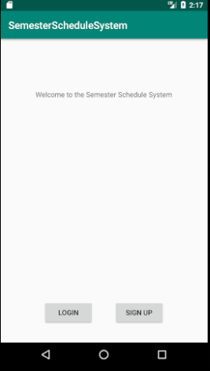

**5.3.2 Admin Registration**

The Admin can register by using official email and password

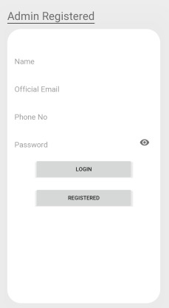

**5.3.3 Admin login**

The Admin login using valid official email and password.

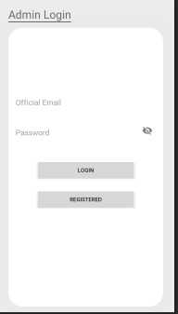

**5.3.4 Faculty Registration**

For registration user enter full name, email, created date and password and then press submit the button to call the PHP file name is user registered.

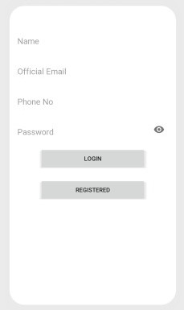

**5.3.5 Faculty Login**

The Faculty login using valid official email and password.

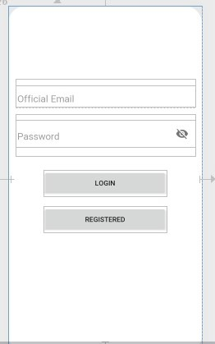

**5.3.6 Student Registered**

The Students enter using their first name, last name, registration number and password and then click the submit button to registered itself.

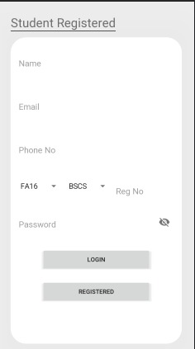

The Students enter their first name, last name, registration number and password and then click the submit button to registered itself.

**5.3.7 Student Login**

The Students enter the registration number and password and then click the submit button to login itself.

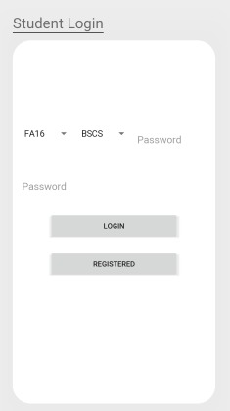

**5.3.8 Faculty panel**

The Faculty checks schedule and notification easily which are mention in faculty panel.

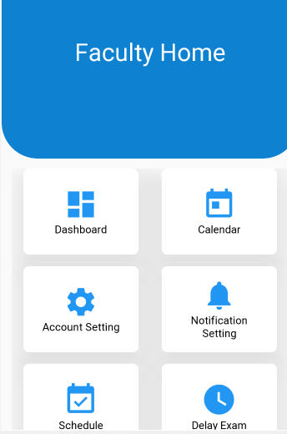

**5.3.9 Student panel**

The Students check schedule and notification easily which are mention in student panel.

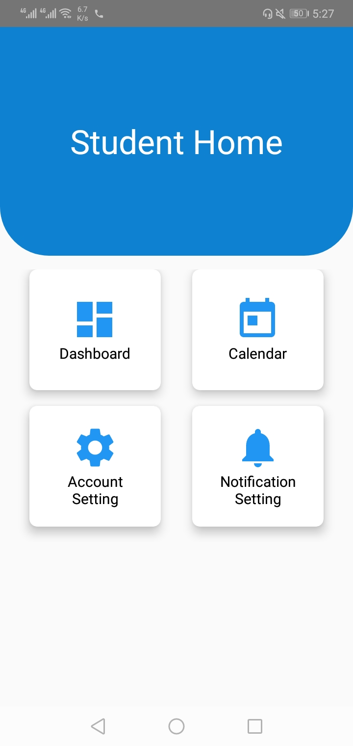

**5.3.10 Calendar**

This section have include schedule which have both student and teacher can see dates.

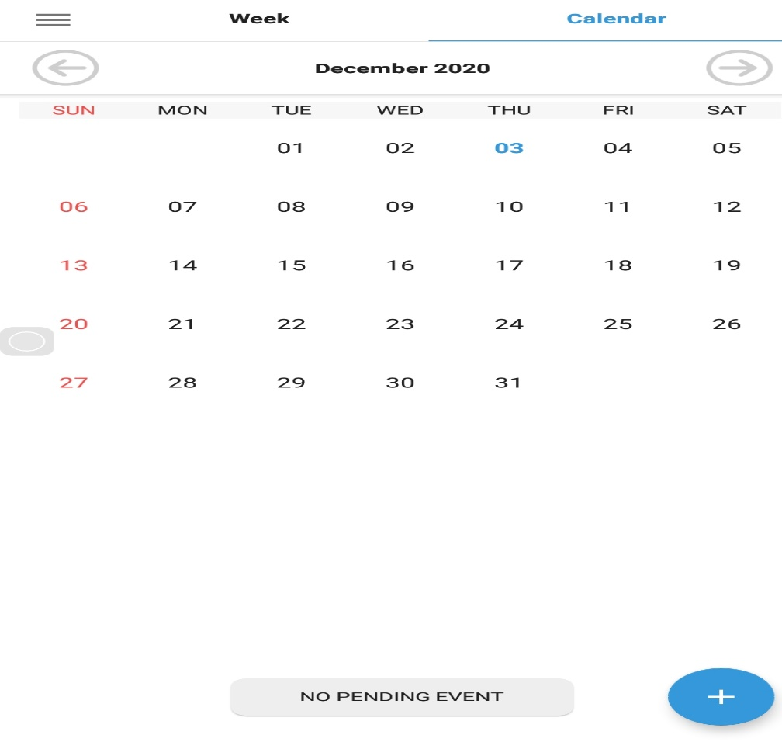

**5.3.11 Week Schedule**

The Students and Teachers can see weekly upcoming events.

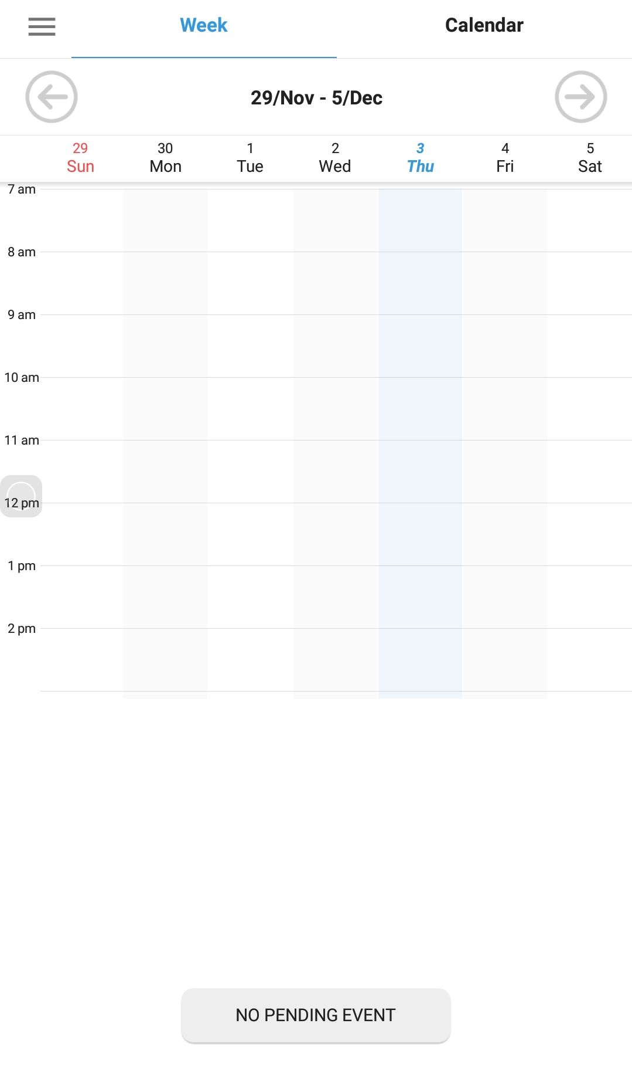

Chapter No 6

Testing and Evaluation

**6.1 Testing**

We focused on testing the entire plan and implementation phase to ensure the stability of the application. When testing the project, I tried to get rid of all the errors and omissions at the time.

**6.1.1 System Testing**

Our system completed successfully and we checked that the system is working fine and we checked all system requirements such as sending requests from Android apps to web services and inserting or fetching data from the database to test performance. The student will login to the system and register the courses who processes the student's submitted application and add assign that courses to the student along teacher name and email. The student sees the schedules set by admin and class teacher so that the student can perform activities accordingly to the deadline of the subject.

**6.1.2 Unit Testing:**

Generally in unit testing we test the smallest functional of the code which are repeatedly use in project. So for that we test the Admin and Teacher registration which we consider as the (User) because these two entities can perform changes in the system. User login and User update password can be performed by these two separate User entities but for the Student registration credentials will be firstly approved by the admin of system to avoid any kind of situation. After that student can login to the system and as well for updating the password student needs admin approval.

6.1.1. User registration

6.1.2. User login

6.1.3. User update password

6.1.4. Student registration

6.1.5. Student login

6.1.6. Student update password

**6.1.2.1 Unit Testing 1:** Registration, Authentication and Update Password of User.

**Testing Objective:** To ensure that user login, registration and update password working correctly.

**Table 6-1 User registration**

|  |  |  |  |  |
| --- | --- | --- | --- | --- |
| **No.** | **Condition** | **Attribute and Value** | **Expected Result** | **Result** |
| 1. | Registered the registration after click the  Registered button | Name: Sir Email: supervisor@ciitattock.edu.pk Created  Date:2020-07-13  Password:123 | Successfully data inserted into the user table in database. | Pass |
| 2. | Verify the user after click the  Login button | Username: supervisor@ciitattock.edu.pk Password:123 | Successfully data select from the user table in database. | Pass |
| 3. | Update the password of user when click the update password button | Username: supervisor@ciitattock.edu.pk  Old  Password:123  New  Password:12345 | Successfully  update the password of user in user table in database. | Pass |

**6.1.2.2 Unit Testing 2:** Registration, Login and Update Password of Student.

**Testing Objective:** Check that the registration, login and password update of working correctly.

**Table 6-2 Student Registration**

|  |  |  |  |  |
| --- | --- | --- | --- | --- |
| **No.** | **Condition** | **Attribute and Value** | **Expected Result** | **Result** |
| 1. | Registered the student after click the registered button | First Name:  Muhammad  Last Name: Bilal  Registration  Number: FA19-  BCS-821  Password:12345 | Successfully data inserted into the student Account table in database.Admin will approve the registration of the student. | Pass |
| 2. | Verify the student after Login button | Registration  Number: FA19-  BCS-  Password:12345 | Successfully data select from the Student Account table in database. | Pass |
| 3. | Update the password of user when click the update password button | Registration  Number: FA19-  BCS-821  Old  Password:12345 | Successfully update password of student Account in student account  table in database. | Pass |

**6.1.4 Functional Testing**

In functional testing mostly tested the main functionality of the system. So in my system we test the main functionally of the system which are below.

6.4.1.1. Web service implementation and call to the web service.

6.4.1.2. Admin response the student submitted application.

6.4.1.3 Admin set the Schedule for Semester

6.4.1.4 Admin set Classes Schedule

6.4.1.5 Teacher set Quizzes and Assignments Schedule

6.4.1.6 Student View All Semester Schedule

6.4.1.7 Notification generated on Teacher Updated

6.4.1.8 Notification Generated on Admin Update

**6.1.4.1 Functional Testing 1: Web service working.**

**Functional testing Description:** Check the web service call and return the JSON format data is working correctly.

**Table 6-3 Web service working.**

|  |  |  |  |  |
| --- | --- | --- | --- | --- |
| **No.** | **Condition** | **Attribute and Value** | **Expected Result** | **Result** |
| 1. | Call to the web service. | Pass URL and method (get or post). | Successfully call to the web service and return data in  JSON format. | Pass |

**6.1.4.2 Functional Testing 2:** User (Admin and Teacher) panel working.

**Functional testing Description:**

Admin will have his panel and Teachers will have its own. Users will check and update the schedule for classes, quizzes and assignments.

**Table 6-4 User panel working**

|  |  |  |  |  |
| --- | --- | --- | --- | --- |
| **No.** | **Condition** | **Attribute and Value** | **Expected Result** | **Result** |
| 1. | Admin: Verify the Profiles for Teachers and Students | Application reply:  Student or Teacher added to the database. Application Status:  Task Performed | Teacher and Student can access their own portals using their credentials . | Pass |
| 2. | Admin will set the schedule by passing input to the System and System will work on algorithms used in building of application. | Application Status: Schedule has been set.  Clearance Status:  Not Inserted. | Set the schedule for whole semester. | Pass |
| 3. | Teacher will set the deadlines for the Quizzes and Assignments. | Application Reply: Notifications will be generated and sent to the students | Students get the notification. | Pass |
| 5. | Updated in deadlines by Users | Student will be notified by the notification. | Notification generated on update | Pass |

**6.1.4.3 Functional Testing 3: Student panel working.**

**Functional testing Description:**

Check the student panel side for submitted registering courses and viewing deadline updated and semester schedules.

## Table 6-5 Student panel working

|  |  |  |  |  |
| --- | --- | --- | --- | --- |
| **No.** | **Condition** | **Attribute and Value** | **Expected Result** | **Result** |
| 1. | Submitted the new application for course registration | Subject: Marks modification.  Description: (name of the course you want to study in this semester if drop earlier in any semester). | Application submitted to the corresponding user. | Pass |
| 2. | View corresponding data updated by User. | Viewing Schedule | Deadlines will be coloured accordingly. | Pass |
| 3. | Request corresponding user for the any convenience. | Subject: Marks modification.  Description: sir please update my assignment marks.  Application reply: marks is changed.  Status: 1 | View the submitted application and status. | Pass |

**6.1.5 Integration Testing**

In integration testing, each modules are combine and tested in group instead of testing it independently, we combine the module and check their impact on each other.

**Table 6-6 Integration Testing Student**

|  |  |  |  |  |
| --- | --- | --- | --- | --- |
| **No.** | **Condition** | **Attribute and Value** | **Expected Result** | **Result** |
| 1 | Registered the student after  click the registered button  OR  Verify the student after  Login button | First Name: Muhammad  Last Name: Bilal Registration Number:  FA19-BCS-821  Password:12345 OR  Registration Number:  FA19-BCS  Password:12345 | Login and registered successfully. | Pass |
| 2 | After student Registered student be able to register course or see the semester schedule. | Student poral view. | After course registration student will be assigned with respective teacher and course deadlines. | Pass |
| 3 | After submit application and admin will approve the application for the student. | Admin will approve the course registration and assign that courses to the students. Student can see semester schedule and as well as the deadlines set by course Teacher. | View the submitted application. | Pass |

**Table 6-7 Integration Testing User**

|  |  |  |  |  |
| --- | --- | --- | --- | --- |
| **No.** | **Condition** | **Attribute and Value** | **Expected Result** | **Result** |
| 1 | Registered the registration after click  the Registered button  OR  Verify the user after click the Login button | Name: Sir supervisor  Email: supervisor@ciitattock.edu.pk CDate:2020-07-13  Password:123  OR  Username: supervisor@ciitattock.edu.pk Password:123 | User successfully login or registered. | Pass |
| 2 | After Login or registered the teacher view the assigned courses and as well as the students registered for that courses. Can set deadlines and can make changes in that | Teacher role is to make sure that the deadline set for quizzes or assignments are the right date and also teacher can communicate with students by broadcasting messages the notification and notification will be sent to the every student registered for the course | Student get the notification for that | Pass |

**6.1.6 Automated Testing**

An automated testing is a test of type where application check on another type of software or tool to check application automatically. So for that I use a firebase test lab, Postman for automated testing to check the functionality of application.

**Tools Used:**

**Table 6-8 Automated Testing**

|  |  |  |  |
| --- | --- | --- | --- |
| **Tool Name** | **Tool Description** | **Applied On** | **Result** |
| Test Lab having Robo  test | This tool provided by the firebase to check the application automatically. | Signed APK | Pass |
| Postman | This software use for testing the web services through which we browse the URL of PHP script. | All the PHP Scripts. | Pass |

Chapter No 7

Conclusion and Future work

**7.1 Conclusion**

In this project the android based application named Semester Schedule System is developed. There are three panels of this application. One is Admin panel Second is faculty panel and third is Student Panel.

By using student panel the students can see one-day early notification related university task and give feedback for any query. Faculty members also use this application for change the quiz and assignment dates and time and see other university activities such as meeting seminar etc. Admin has rights to Add details for the whole semester for starting date to ending. In this, he will define the whole schedule of the semester such as course registration, fee 1st instalment, quiz, assignment. Course drop, sessional 1 sports week, course withdraw, sessional 2, seminar terminal and final result display. This system facilities the students and faculty by saving their time and reduces the efforts of students and teachers. Semester schedule system provides the complete calendar of the semester

**7.2 Future Work**

This application is developed only for university students but in future, this app will be changed to college and school level. More future will be added in this app like class timing,

Fee information section and student marks portal. In further student-teacher panel give access to display student quizzes, assignments marks in student’s marks panel.

Chapter No 08

References

**8.1 References**

[1] <https://www.youtube.com/results?search_query=calendaralgorithm+in+phython>

**Description:** calendar algorithm using python language

[2] https://www.tutorialspoint.com/android/android_php_mysql.htm

**Description:** How to Send the request from android application to the web service.

[3] <https://www.androidhive.info/2012/05/how-to-connect-android-with-php-mysql/>

**Description:** How to connect the android with PHP and MySQL server database.

[4] https://www.youtube.com/watch?v=7zaKUc2zfpI

**Description:** How to create the table layout and fragment layout in android studio.

[5] https://www.journaldev.com/9412/android-shared-preferences-example-tutorial **Description:** How to implement the shared Preferences in android.

[6] <https://romannurik.github.io/Android> Asset Studio/

**Description:** How to make Launcher icon generate.

[7] https://www.javatpoint.com/what-is-andddroid layout **Description:** what is constrain service?

[8] https://abhiandroid.com/programming/asynctask

**Description:** How to implement the AsyncTask methods in android

[9] https://www.simplifiedcoding.net/android-upload-image-to-server/

**Description:** How to upload the image from application to web service.

1. https://square.github.io/okhttp/recipes/

**Description:** Okkhttpclient library use for the web service call.

1. https://codinginflow.com/

**Description:** implementation of Recycler View and Json format data in android.